STOCKLOT OF HI-QUALITY FLAT WARES
*These flat wares are made from hi-quality stainless steel and excellent workmanship.
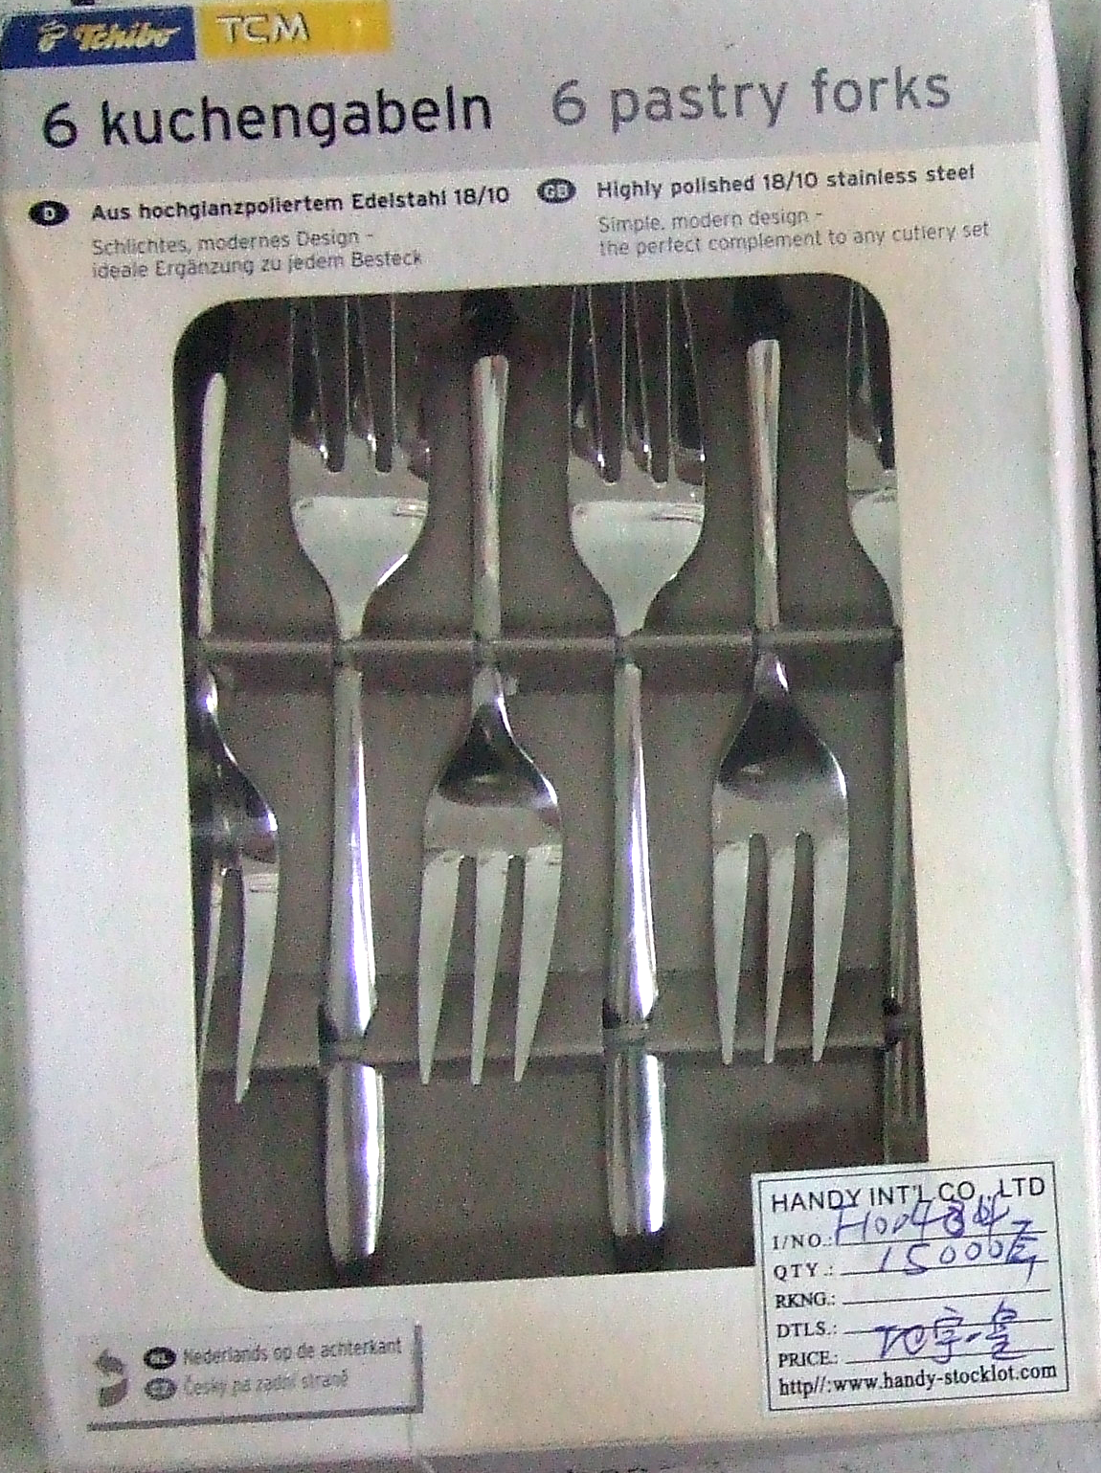 | 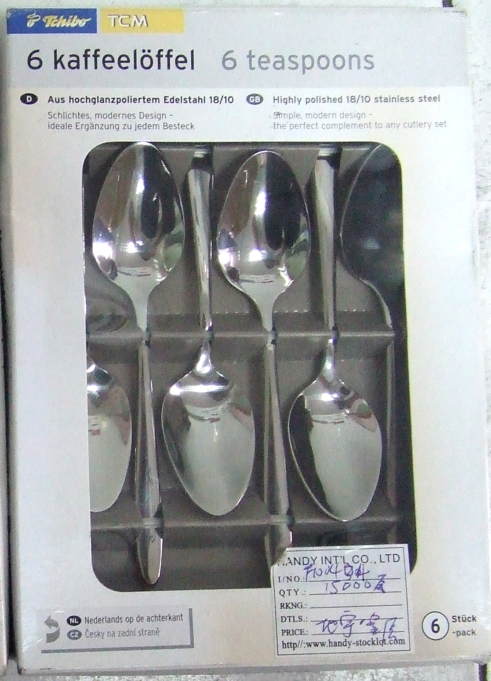
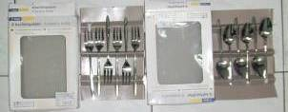 | 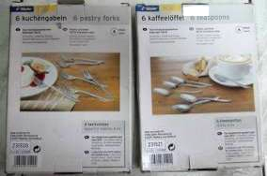
F100504-1 HI-QUALITY PASTRY FORK SET- 6 pcs/set, hi-quality stainless steel, with delicate workmanship. Spoon length 15.5 cm. Each set in a printed gift box. Packing: 40 sets/ctn/0.043 cbm/1.54 cuft.  Q’ty: 16,000 sets  FOB US$1.25/set | F100504-2 HI-QUALITY TEASPOON SET- 6 pcs/set, hi-quality stainless steel, with delicate workmanship. Spoon length 13.5 cm. Each set in a printed gift box. Packing: 40 sets/ctn/0.043 cbm/1.54 cuft.  Q’ty: 16,000 sets  FOB US$1.25/set

